Research: China Online Poker Glimpse
Short brief about the law against online poker in China, how does it work?
Online gambling is illegal in China, making online poker games essentially dead in the country. There are no Chinese legally owned or operated poker sites. As far as the players go, they aren’t breaking the law because it’s not against the law to gamble online, but this still doesn’t mean the government wishes people to play. China is well known for its censoring of the internet and can and will block any websites it does not feel to be appropriate for its people, and this includes gambling and online poker websites.
Despite this, players have found ways and means to play online. And online operators are becoming more innovative in their offerings by not having “real money” transactions but instead use alternatives that can be converted to cash. Officials here do realize that given that there are no Chinese online poker sites, no one is breaking the law as far as far as operating these sites, as the Chinese recognize that these sites are outside their jurisdiction, something that not all countries properly admit to. But once again, in China, Mah-jong and poker games are taken off the approval list following a wave of earlier government crackdowns over concerns that such titles may connected to illegal gambling.

Can people download poker apps?
June 2018, a major crackdown, known as Chinese Black Friday, occurred in China. The government banned all online poker applications, removing them from App Stores, and going as far as forbidding the promotion of Poker on any Social Media. It’s not that they always block poker websites, but this can certainly happen here, although the first thing you need to know is that this blocking is limited to the online poker website itself. People aren’t blocked from playing there, the most they can be blocked from is downloading the software, and once they do that, they are in the clear.
The Chinese have been well accustomed to getting around censorship, and the use of virtual private networks (VPN) to access the internet is very popular in general because of the Great wall firewall, and this is the tool that online poker players use to get around these poker related restrictions.
So, all you do is log on to the network and then you can travel to any site you wish without government detection, Android APK and IOS "Enterprise" workaround solves the problem. So there are now a lot of online poker players living in China and while there is still a lot of room for growth, as not everyone is aware of this means of playing, the market here is expected to continue to grow.

Can people pay for the online apps? How online payment works for those apps?
Yes, they can, but not through an official way. We all understand the APP is totally free but for playing games need real money. Taking example of Poker Master, which is not a cash deposit site, player can do an in-app purchase for getting some virtual items, but for playing in the games their funds will flow to home game host or the agent who raises the game with gateway/mobile payment methods. Taking example of Poker King, which is a cash deposit site, they have payment service provider to allow players directly deposit/withdrawal with both gateway/mobile payment methods.
Information about prices of poker apps and prices of all features inside poker apps.
Platform | Store/Mall | Items | Includes | Price
Poker Master * | Coins Package | Bronze Package | 600 + 20 Coins | 60 Gems
 |  | Silver Package | 3000 + 200 Coins | 300 Gems
 |  | Gold Package | 12800 + 1000 Coins | 1280 Gems
 |  | Dimond Package | 32800 + 4000 Coins | 3280 Gems
 |  | Gold Card (1 Month) | Allow 3 clubs + 3 games at the same time | $ 4.99
 |  | Platinum Card (1 Year) | Allow 5 clubs + 5 games at the same time | $ 49.99
 | Gem Store | 60 Gems |  | $ 0.99
 |  | 300 Gems |  | $ 4.99
 |  | 1280 Gems |  | $ 19.99
 |  | 3280 Gems |  | $ 49.99
 |  | 6180 Gems |  | $ 94.99
Red Dragon Poker * | Gift Package | Spadie Gift | 600 + 20 Coins | ¥ 6
 |  | Heart Gift | 3000 + 200 Coins | ¥ 30
 |  | Club Gift** | 12800 + 1000 Coins | ¥ 128
 |  | Diamond Gift | 32800 + 4000 Coins | ¥ 328
 |  | VIP Card | Valid for 30 days, check privileged data | ¥ 30
 | Lucky Charm | Tangerine | Available for 3 days | 88 Coins
 |  | Clover | Available for 3 days | 88 Coins
 |  | Magatama | Available for 3 days | 188 Coins
 |  | Wine** | Available for 3 days | 188 Coins
 |  | Wreath | Available for 3 days | 288 Coins
 |  | Cigar | Available for 3 days | 288 Coins
 |  | Duck | Available for 3 days | 688 Coins
 |  | Ruby | Available for 3 days | 688 Coins
 |  | 777** | Available for 3 days | 888 Coins
Note: * screenshots attached, ** means in-app best seller
Poker Master Store/Mall
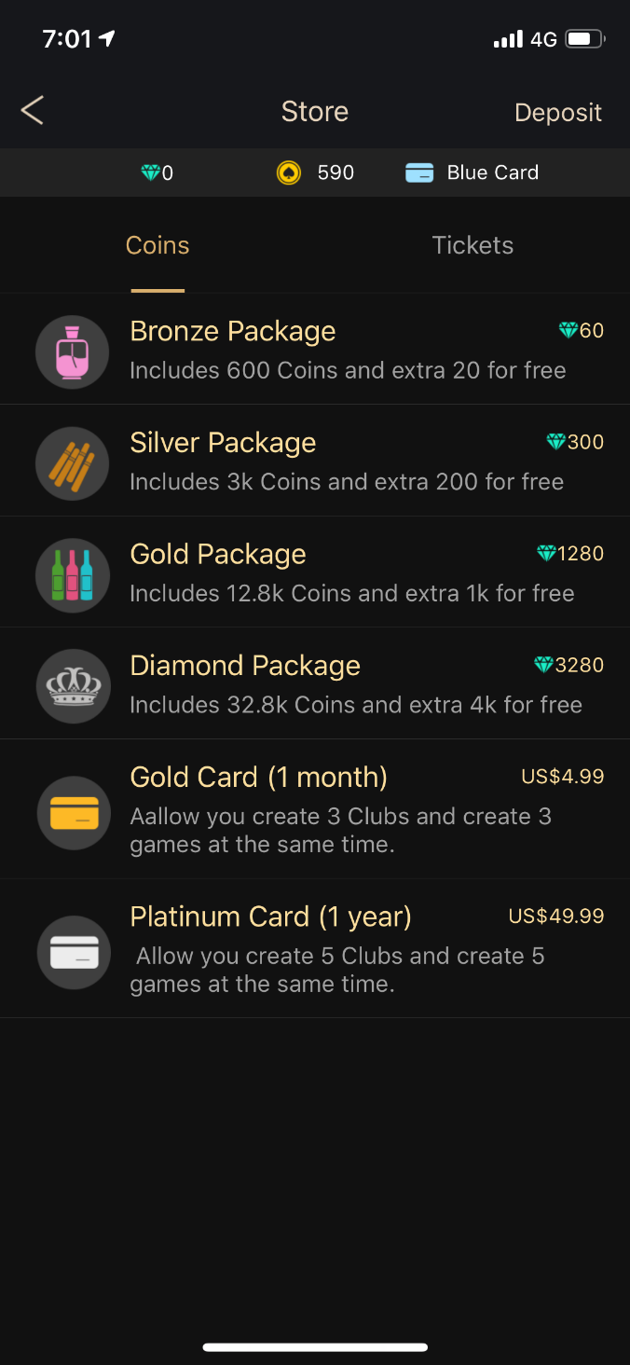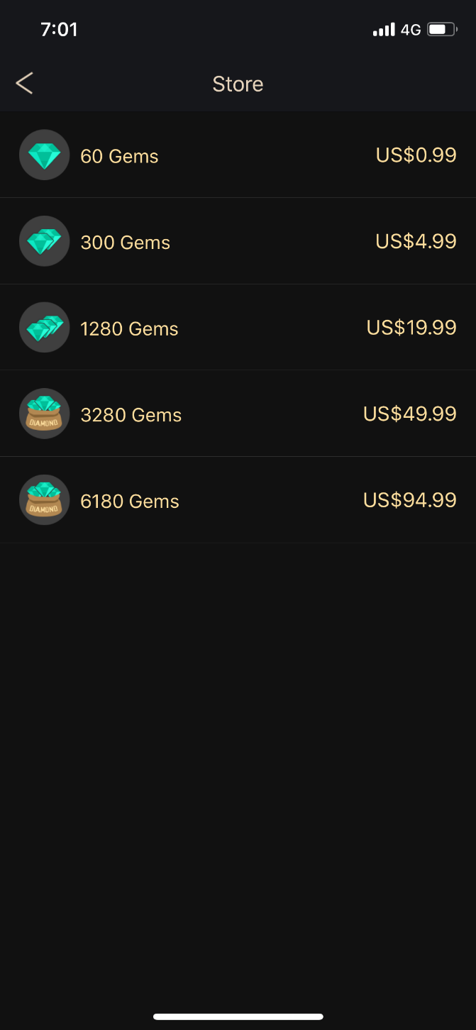

Red Dragon Poker Store/Mall
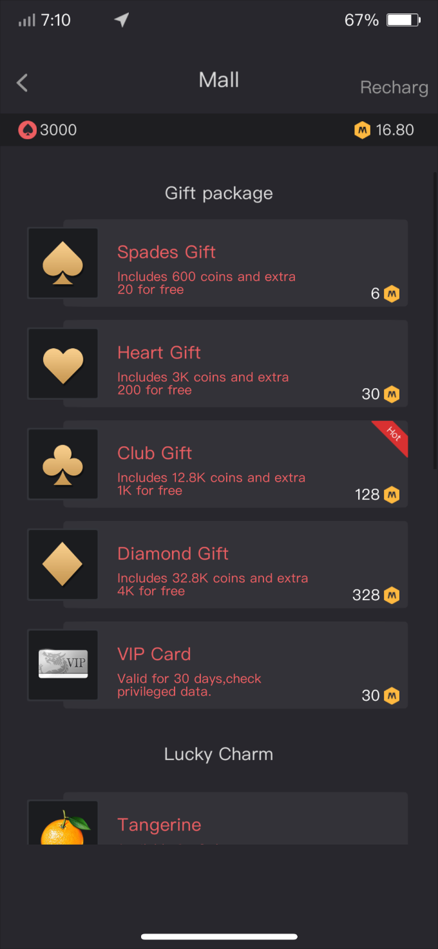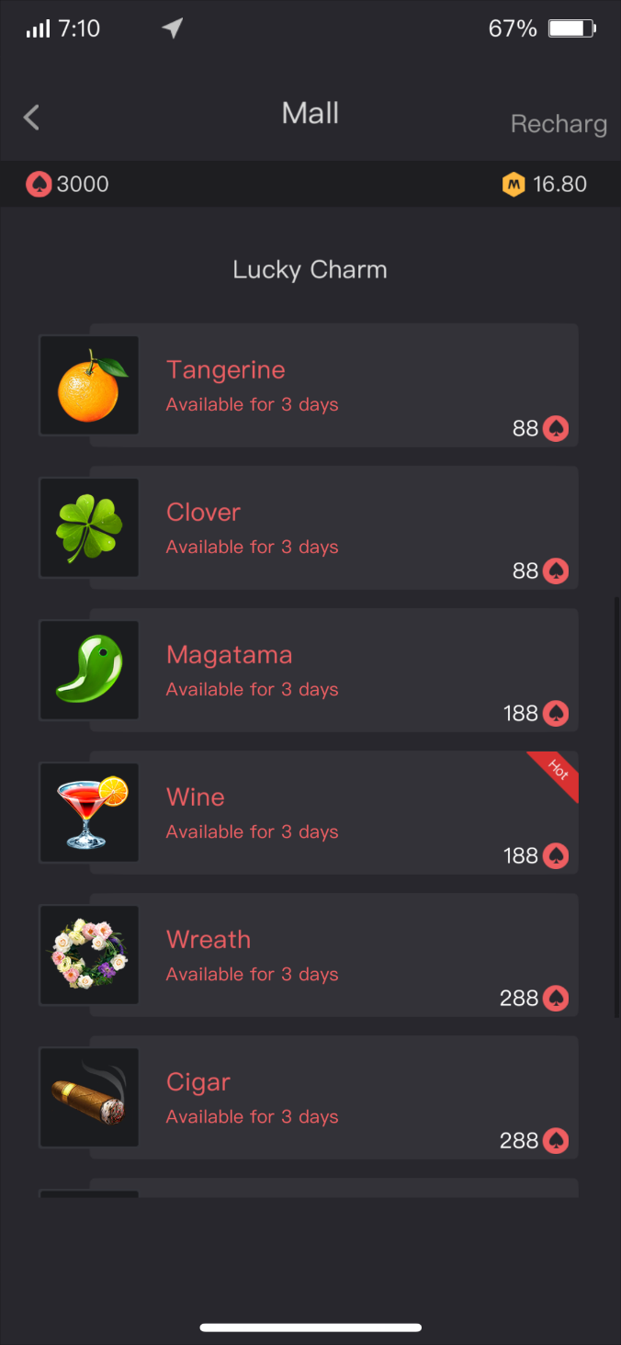

How player pays in Poker King Club?
1. Player goes to their cashier for deposit. Ali Pay and Union Pay was recommended here.
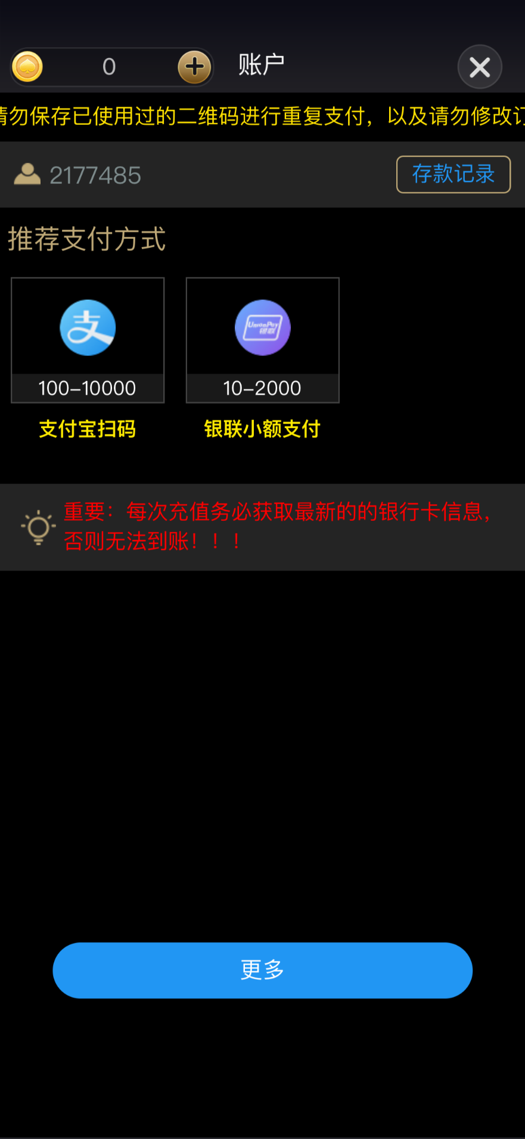

Union Pay
Ali Pay

2. Player choose Ali Pay, select amounts for getting payment QR code.
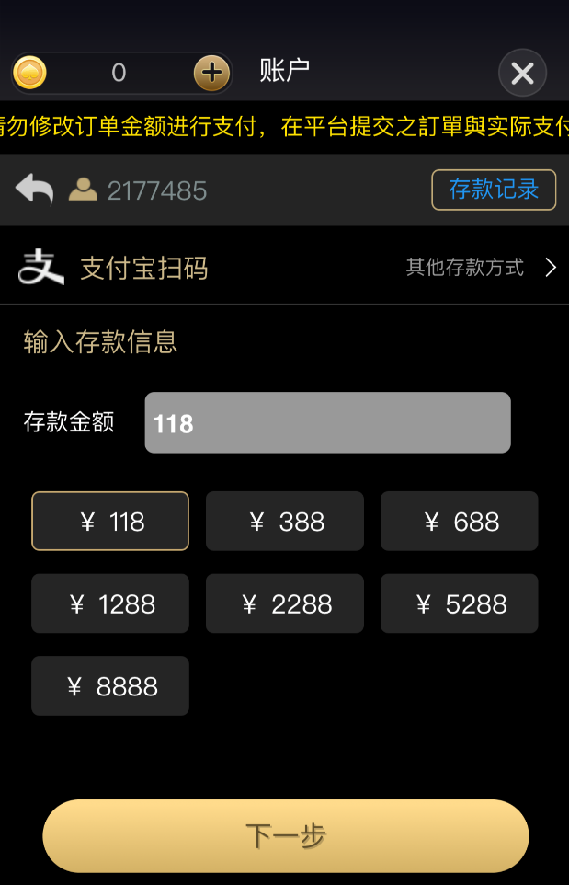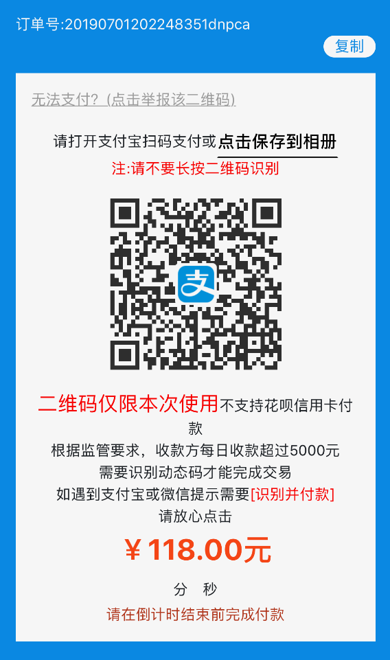

3. Player choose Union Pay, select amounts and go to payment page.
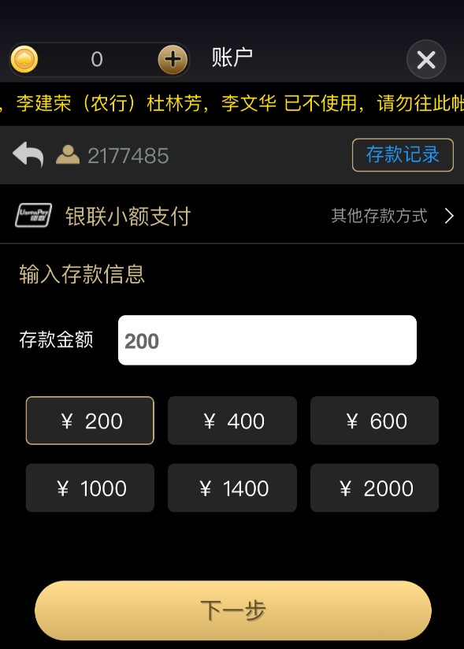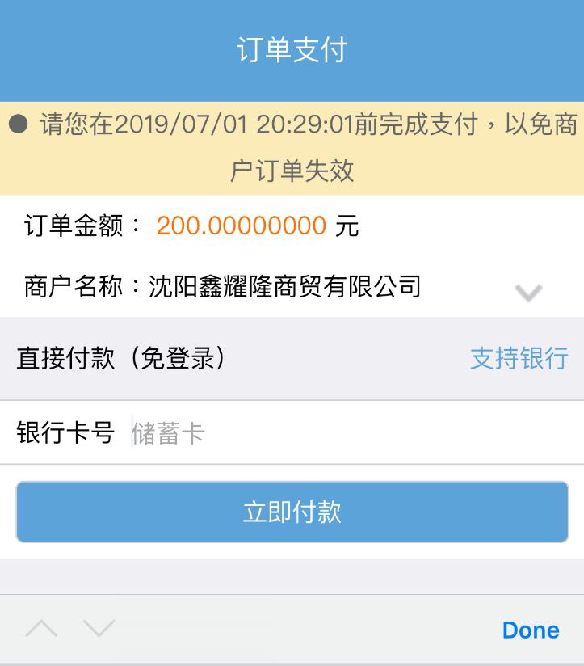

How player pays in Red Dragon Poker?
1. From App’s wallet tab, press the “Trade” button
RD Badge Balance
RD Points Balance

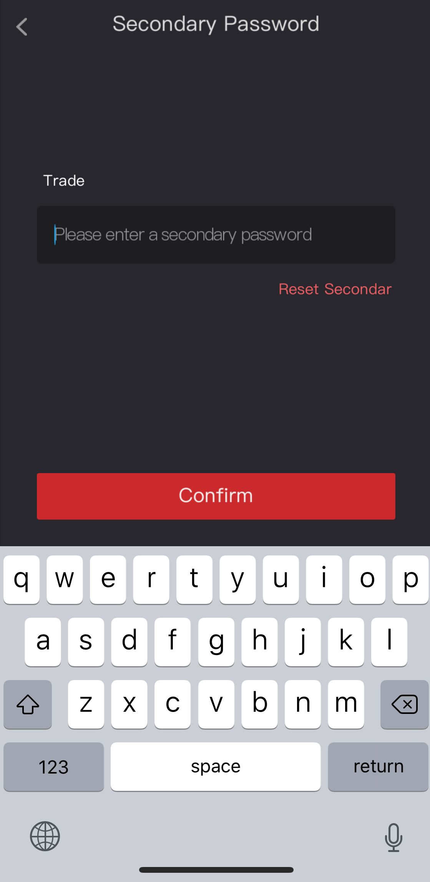
2. You will be asked to type in a secondary password to enter that.

3. Redirect to a page named “Trade Centre” with a bunch of trade dealers listed.
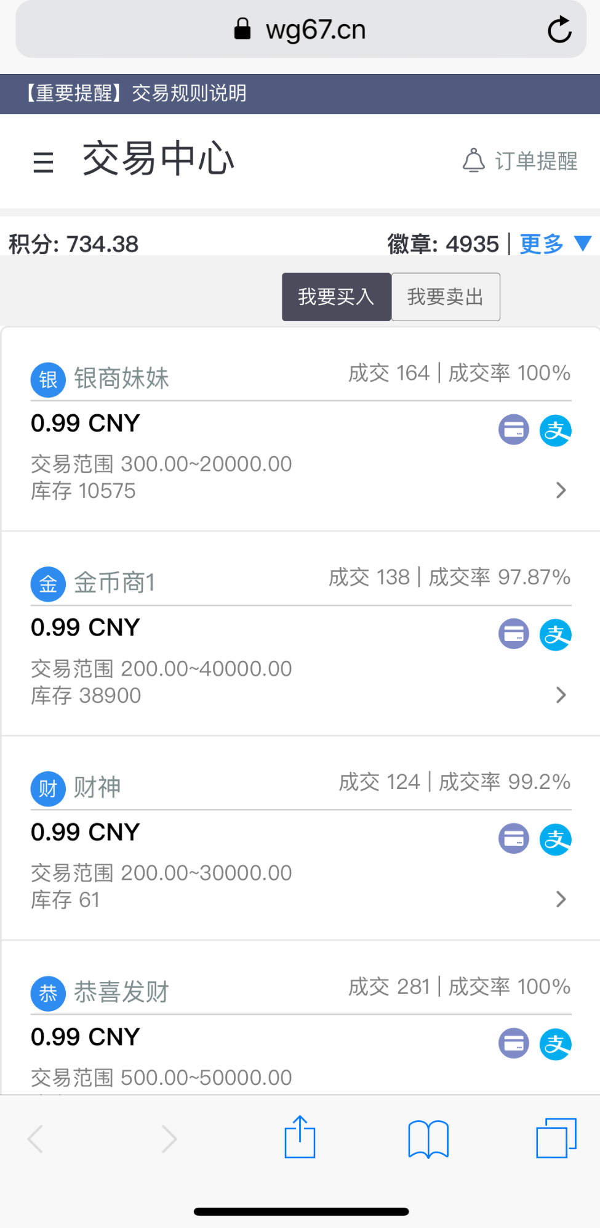

Trader Centre

Your Badge Balance
Your Pts Balance

Sell Pts
Buy Pts

Successful transactions
Merchants’ Name

Exchange Rate
Payment Option

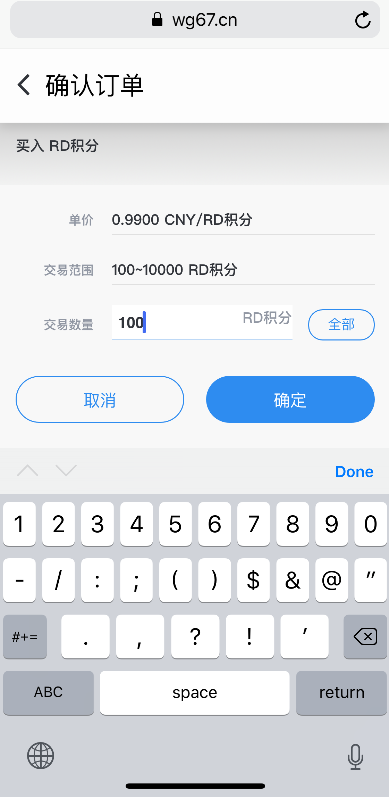
4. E.g. Press one merchant and goes to an order page, type in the pts you want to buy.

Order

Exchange Rate

Available amount

Place your order amount

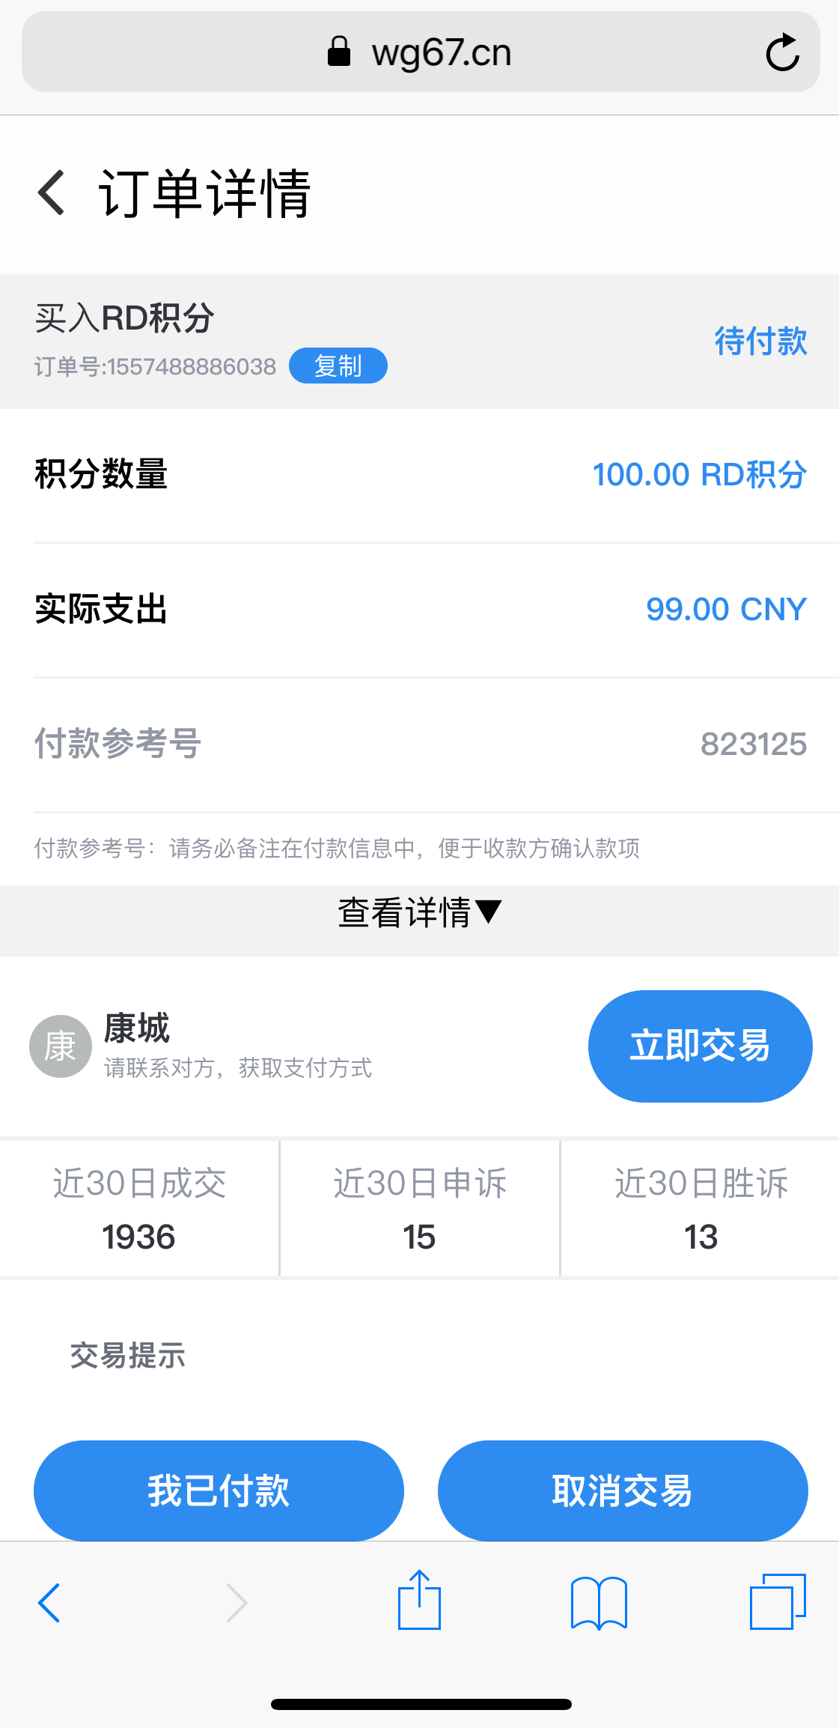
5. Confirm page for order with exchanged amount for a further confirm.

Confirm Order Details

Buy RD Points

Buy RD Points

Player to Pay

Merchants’ Detail and History

Confirm and buy

Cancel the deal
I’ve paid already

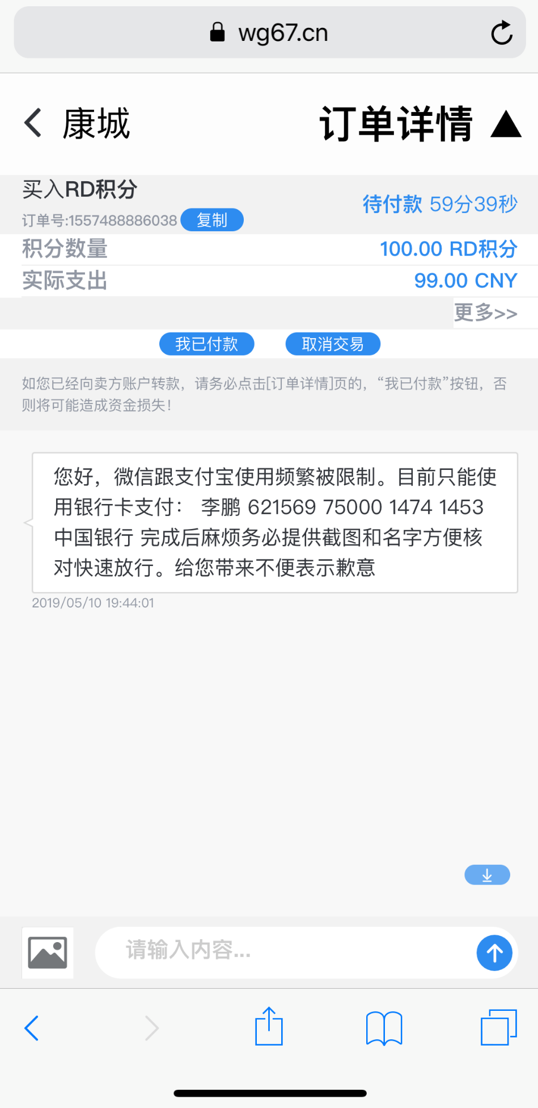
6. Final page for transaction with live chat to merchants, confirm your payment options (WeChat Pay, Ali Pay or bank transfer to merchants’ account) and then finish the transaction. All merchants are individual agents.

Merchants’ Name

Cancel the deal
I’ve paid already

Live Chat Box with Merchant’s CS agent

